**Controllable Canonical Form (CCF)**

Probably the most straightforward method for converting from the transfer function of a system to a state space model is to generate a model in "controllable canonical form."  This term comes from Control Theory but its exact meaning is not important to us.  To see how this method of generating a state space model works, consider the third order differential transfer function:

http://lpsa.swarthmore.edu/Representations/SysRepTransformations/TF2SS/img53.gif

We start by multiplying by Z(s)/Z(s) and then solving for Y(s) and U(s) in terms of Z(s).  We also convert back to a differential equation.

http://lpsa.swarthmore.edu/Representations/SysRepTransformations/TF2SS/tf2ss_CCF.png

We can now choose z and its first two derivatives as our state variables

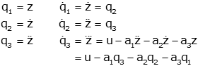

Now we just need to form the output

http://lpsa.swarthmore.edu/Representations/SysRepTransformations/TF2SS/img5E.gif

From these results we can easily form the state space model:

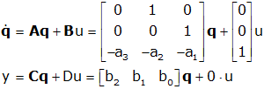

In this case, the order of the numerator of the transfer function was less than that of the denominator.  If they are equal, the process is somewhat more complex.  A result that works in all cases is given below; the details are [here](http://lpsa.swarthmore.edu/Representations/SysRepTransformations/TF2SS_CCF_OCF_hard.html#Controllable).  For a general nth order transfer function:

http://lpsa.swarthmore.edu/Representations/SysRepTransformations/TF2SS/img70.gif

the controllable canonical state space model form is

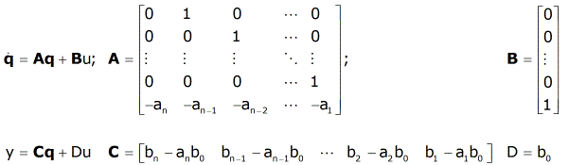

**Key Concept: Transfer function to State Space (CCF)**

For a general nth order transfer function:

http://lpsa.swarthmore.edu/Representations/SysRepTransformations/TF2SS/img70.gif

the controllable canonical state space model form is

